|  |  |  |  |  |
| --- | --- | --- | --- | --- |
|  |  |  |  |  |
|  |  |  |  |
|  |  |  |  |
|  |  |  |  |
|  |  |  |  |
|  |  |  |  |
|  |  |  |  |

|  |  |  |  |  |
| --- | --- | --- | --- | --- |
|  |  |  |  |  |
|  |  |  |  |
|  |  |  |  |
|  |  |  |  |
|  |  |  |  |
|  |  |  |  |
|  |  |  |  |

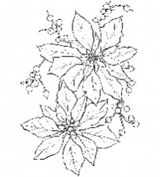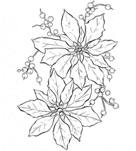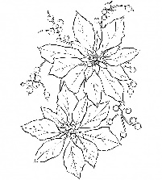

新北市鶯歌區鶯歌國民小學一一一學年度

【心正書法教學中心】暨【學生文康中心】啟用誌慶

學生硬筆書法比賽(中年級組)

新北市鶯歌區鶯歌國民小學一一一學年度

【心正書法教學中心】暨【學生文康中心】啟用誌慶

學生硬筆書法比賽(中年級組)